**1. Explain telnet, ftp, and ssh commands.**

Ans:

**1. Telnet (Telecommunication Network)**

Telnet is a protocol that allows you to connect to remote computers over a network and interact with them as if you were logged in locally. It transmits data in plain text, including usernames and passwords, making it insecure for modern use over the Internet. However, it can still be used in controlled or private networks for tasks like configuring network devices, which is why it is not used in companies nowadays.

Command:

To connect to a remote machine: telnet <hostname or IP address>

Example: telnet 192.168.1.10

**2. FTP (File Transfer Protocol)**

FTP is a protocol used to transfer files between a client and a server on a network. It operates over a command channel (usually on port 21) and can use either active or passive mode for data transfer. Like Telnet, FTP transmits data in plain text, including credentials, making it insecure for use on the open internet without additional security measures like FTP over SSL (FTPS).

Commands:

To connect to an FTP server: ftp <hostname or IP address>

To upload a file: put <filename>

To download a file: get <filename>

Example:

ftp 192.168.1.10

username: your_username

password: your_password

get example.txt

**3. SSH (Secure Shell)**

SSH is a protocol that provides a secure channel over an unsecured network, enabling secure remote login and command execution on other computers. SSH encrypts the connection, including the transmission of credentials and data, making it the preferred choice for secure remote management. It uses public-key cryptography to authenticate the remote computer and allow it to authenticate the user if necessary.

Command:

To connect to a remote machine: ssh <username>@<hostname or IP address>

Example: ssh user@192.168.1.10

**2. Create a file commands.txt. write Linux commands in it.**

**Ans:** 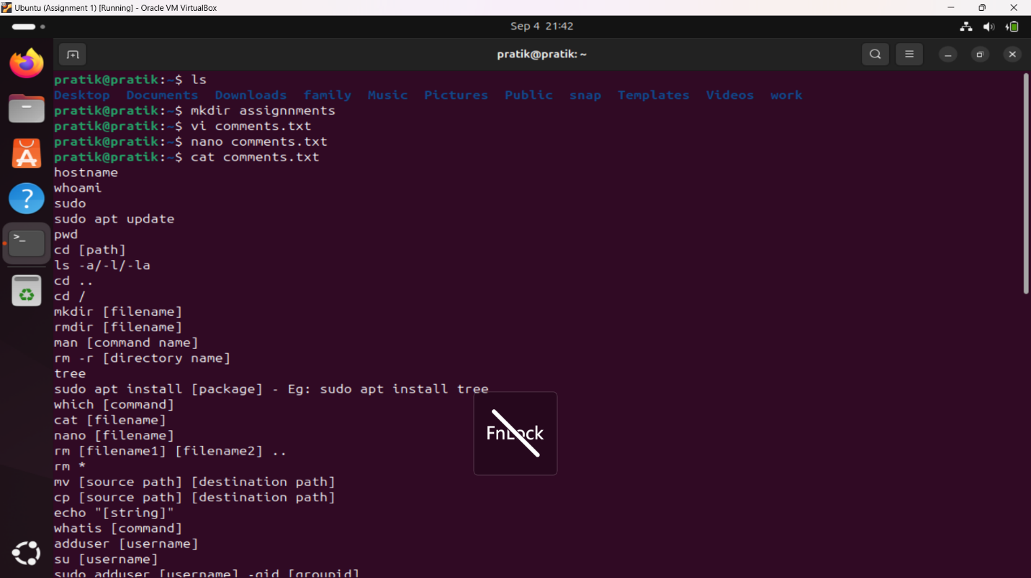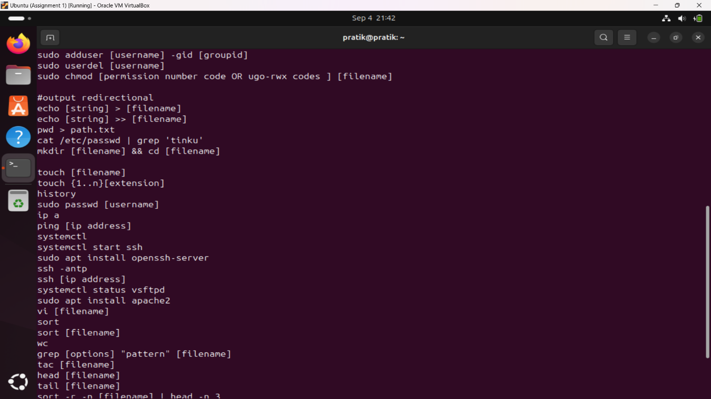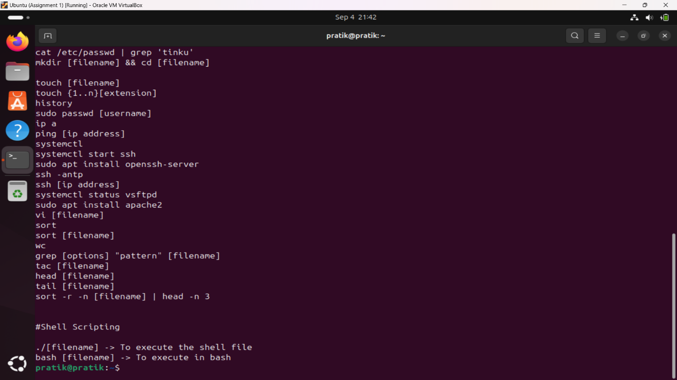

3. Count words in that file. Sort contents of file in reverse order.  
search the word “ls” in this file .

4.[count the number of lines](http://man7.org/linux/man-pages/man1/wc.1.html) in the file that contain "pwd”

5. Write a command that do not display lines containing “dbda”.

Ans: 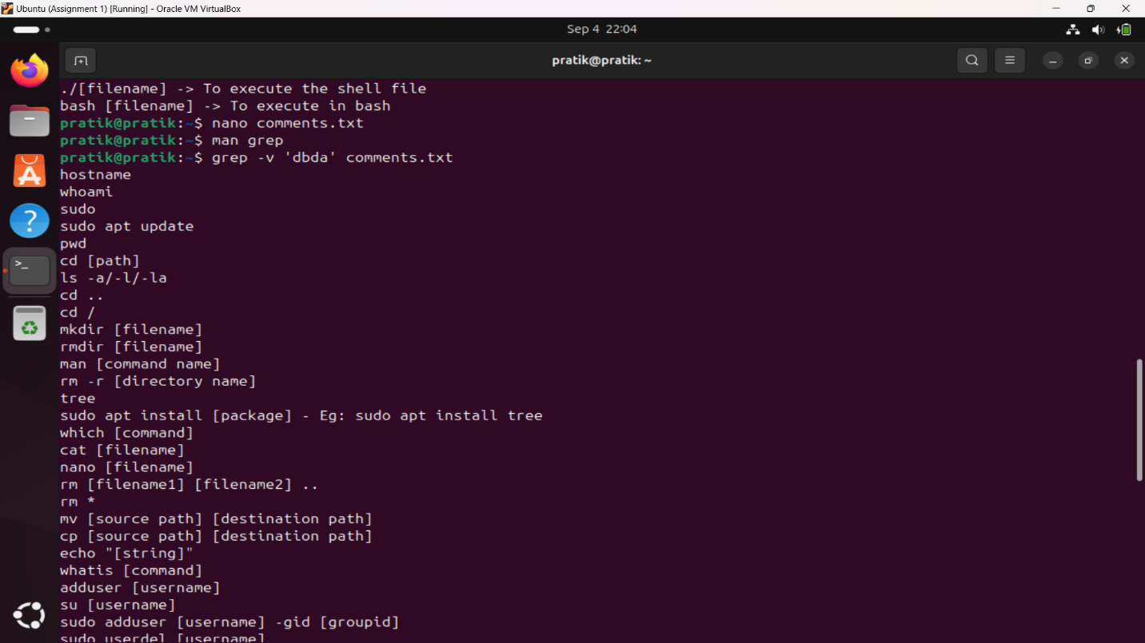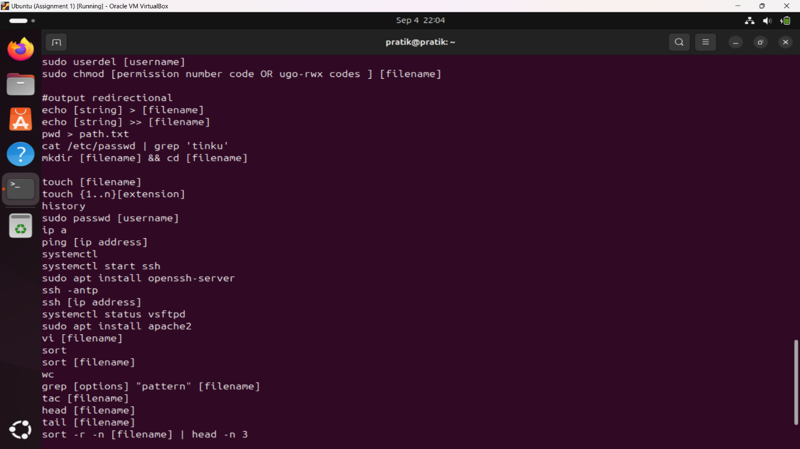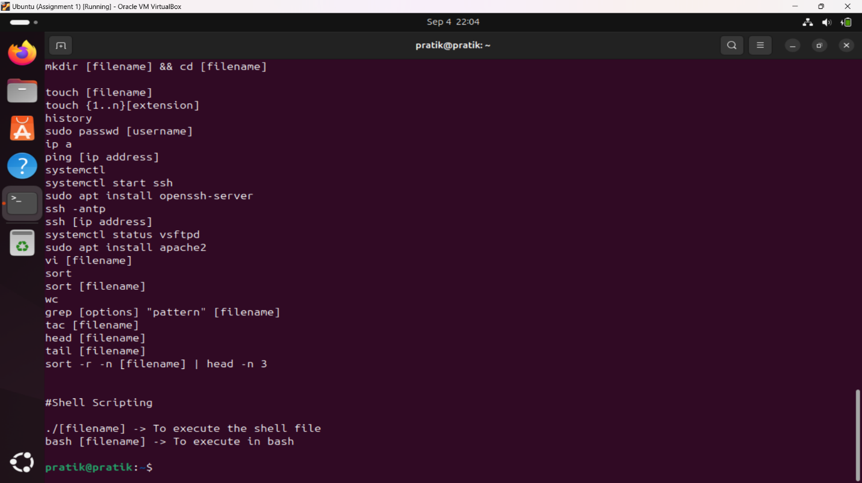

6. List all files and directories and give them as input to `grep` command using piping store in file.txt

Ans: 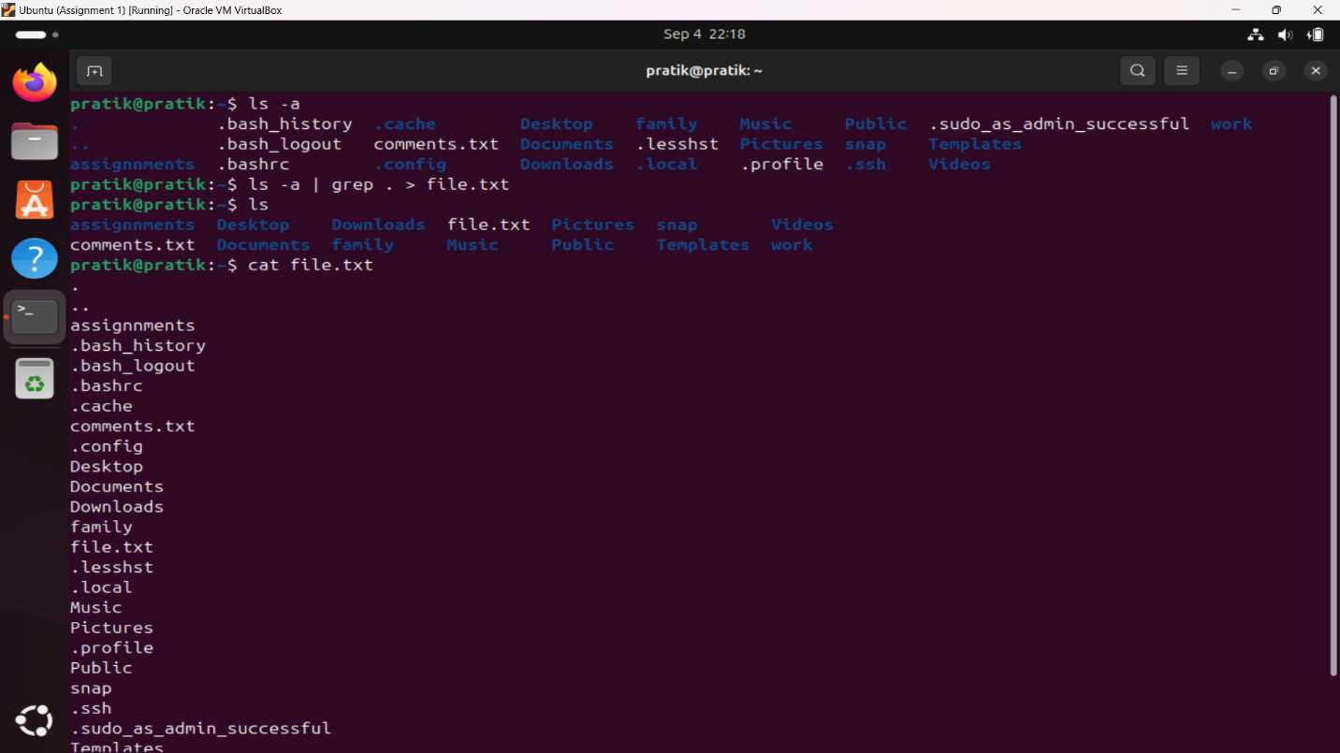

7. Sort file.txt

8. Write a Shell Script to find the maximum between three numbers.

9. Write a Shell Script to check whether a number is negative, positive or zero.

10. Write a Shell Script to check whether a number is divisible by 5 and 11 or not.

11. Write a Shell Script to check whether a number is even or odd.

Ans: 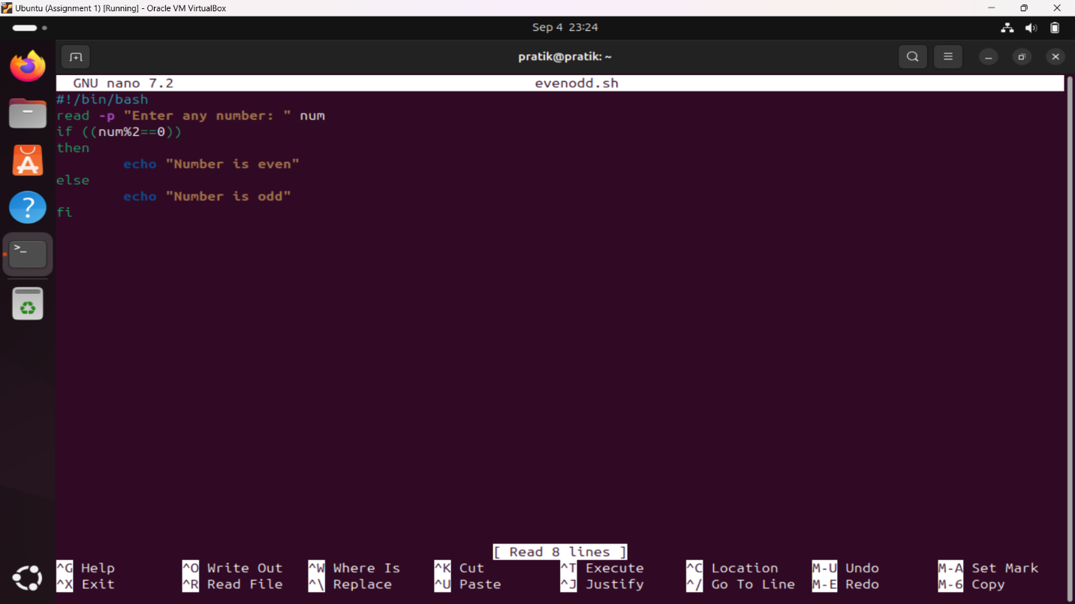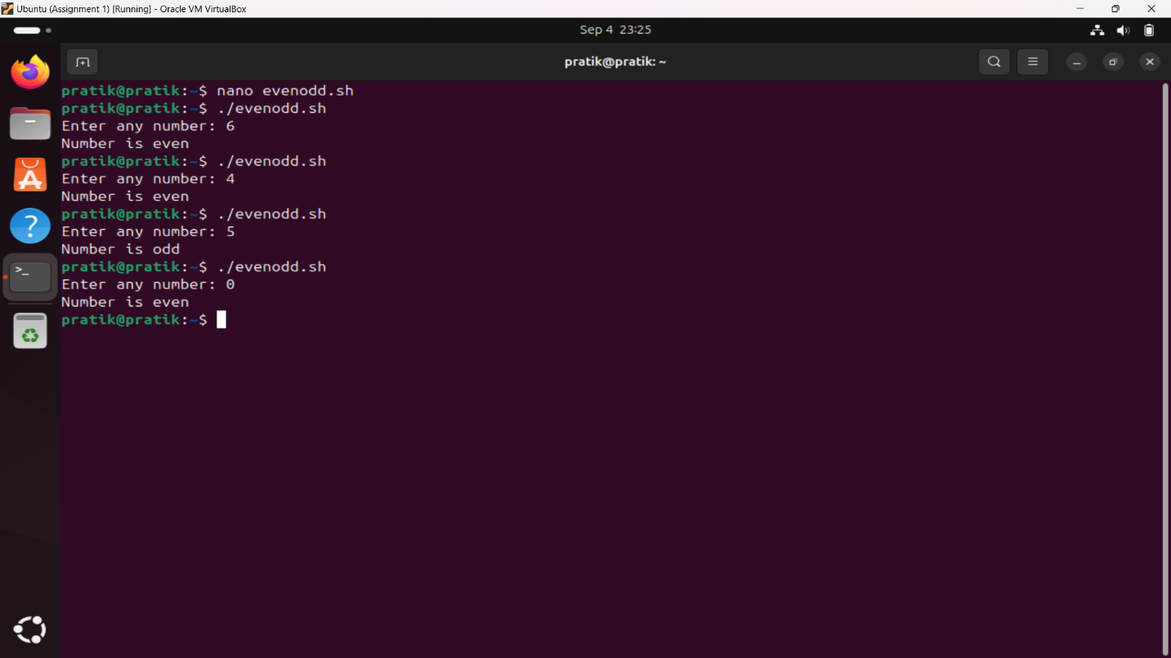

12. Write a Shell Script to check whether a year is leap year or not.

Ans: 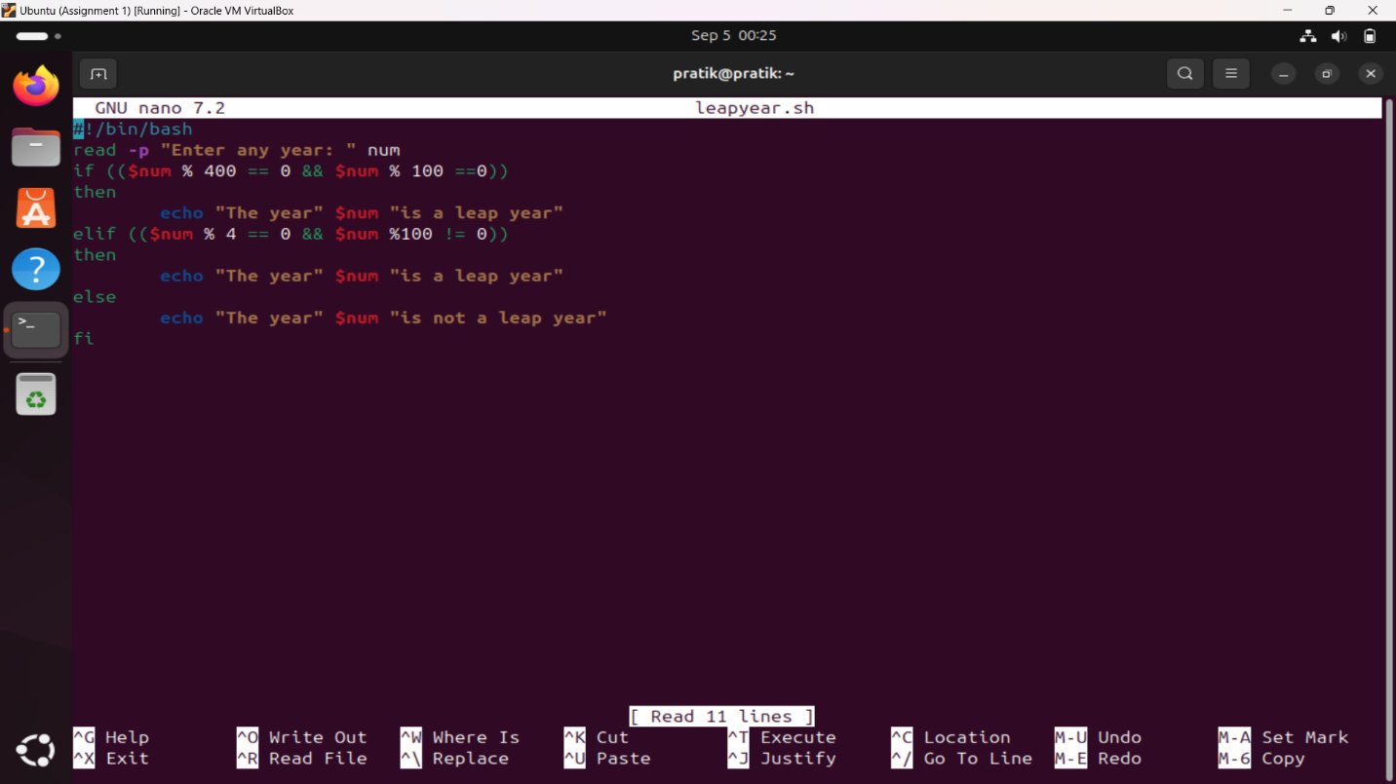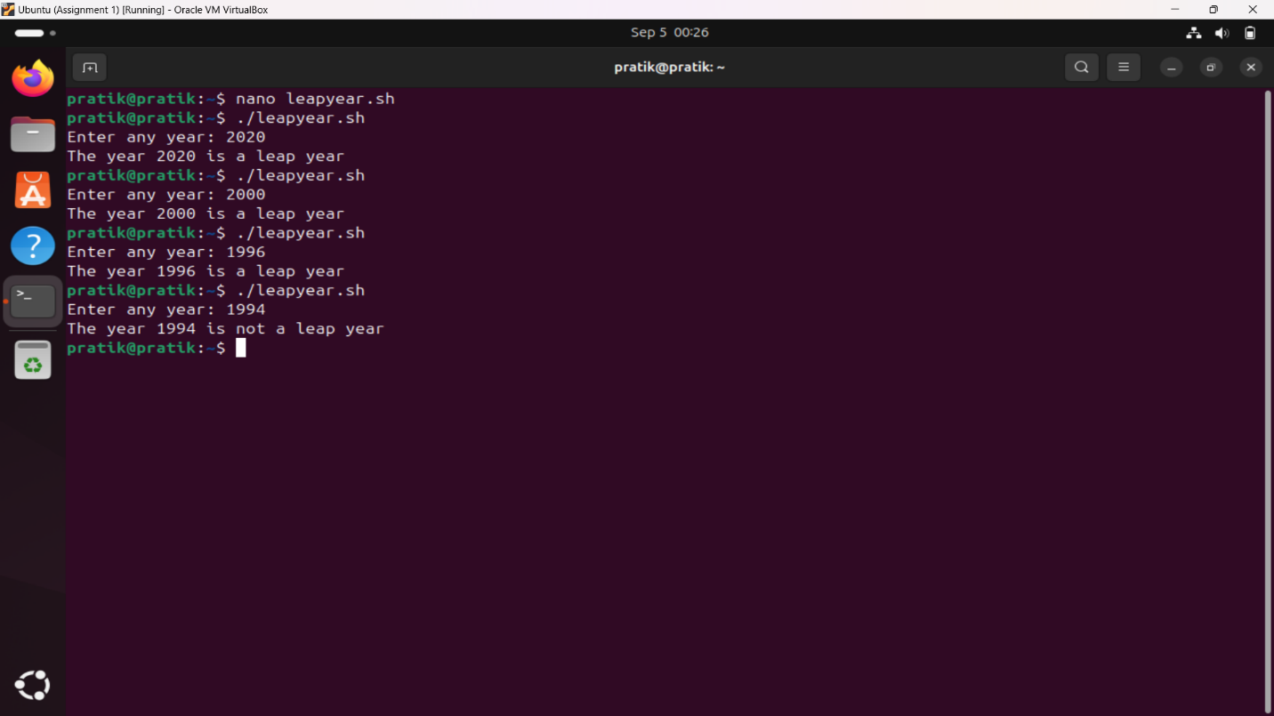

13. Write shell script to check eligibility of candidate for voter id card

14. Shell Script to display the first 10 natural numbers.

